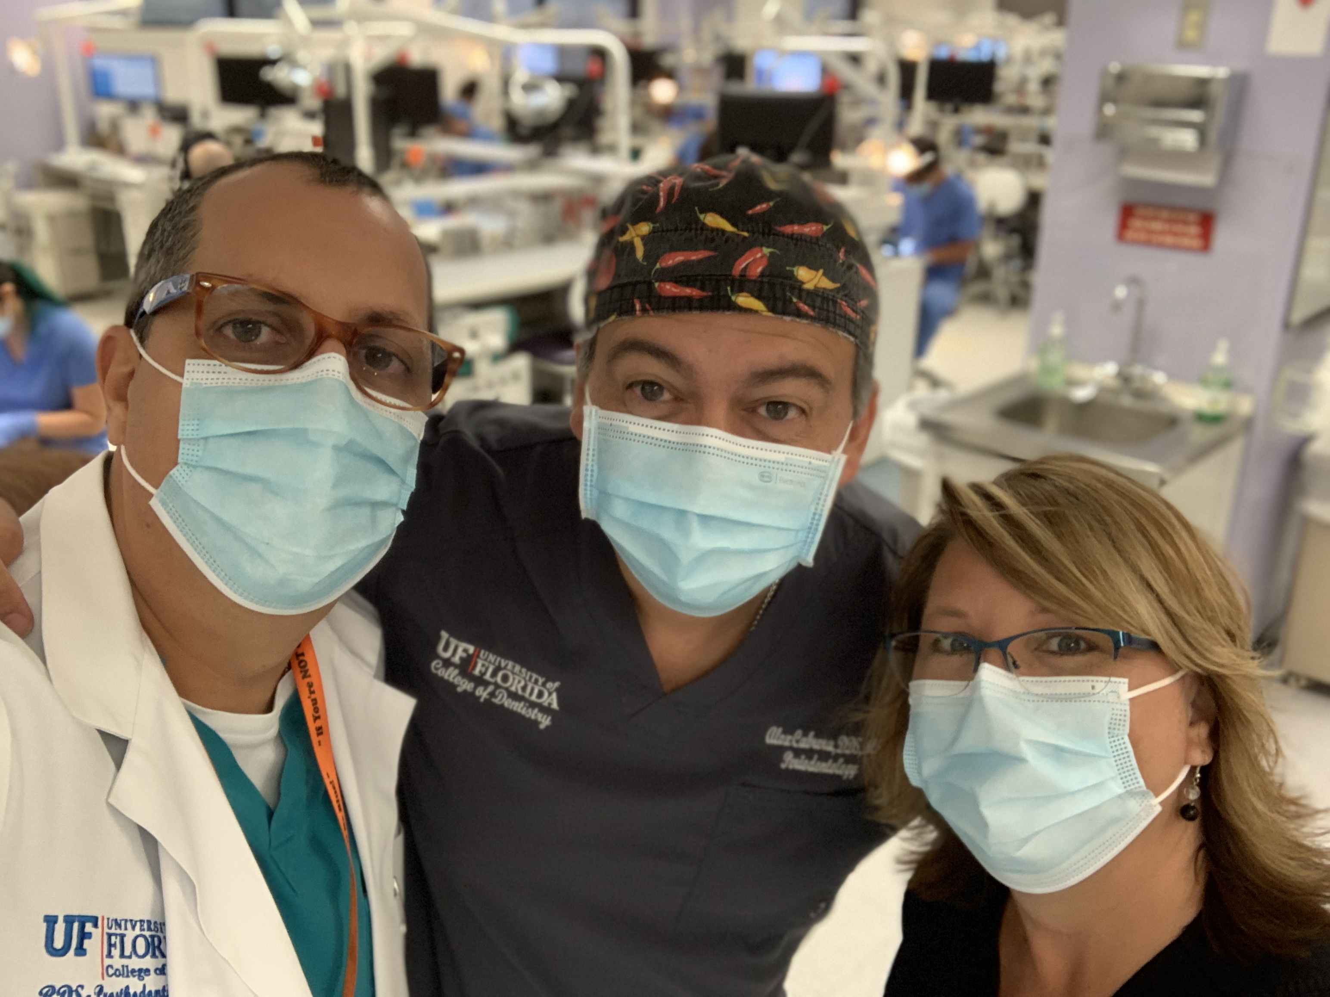
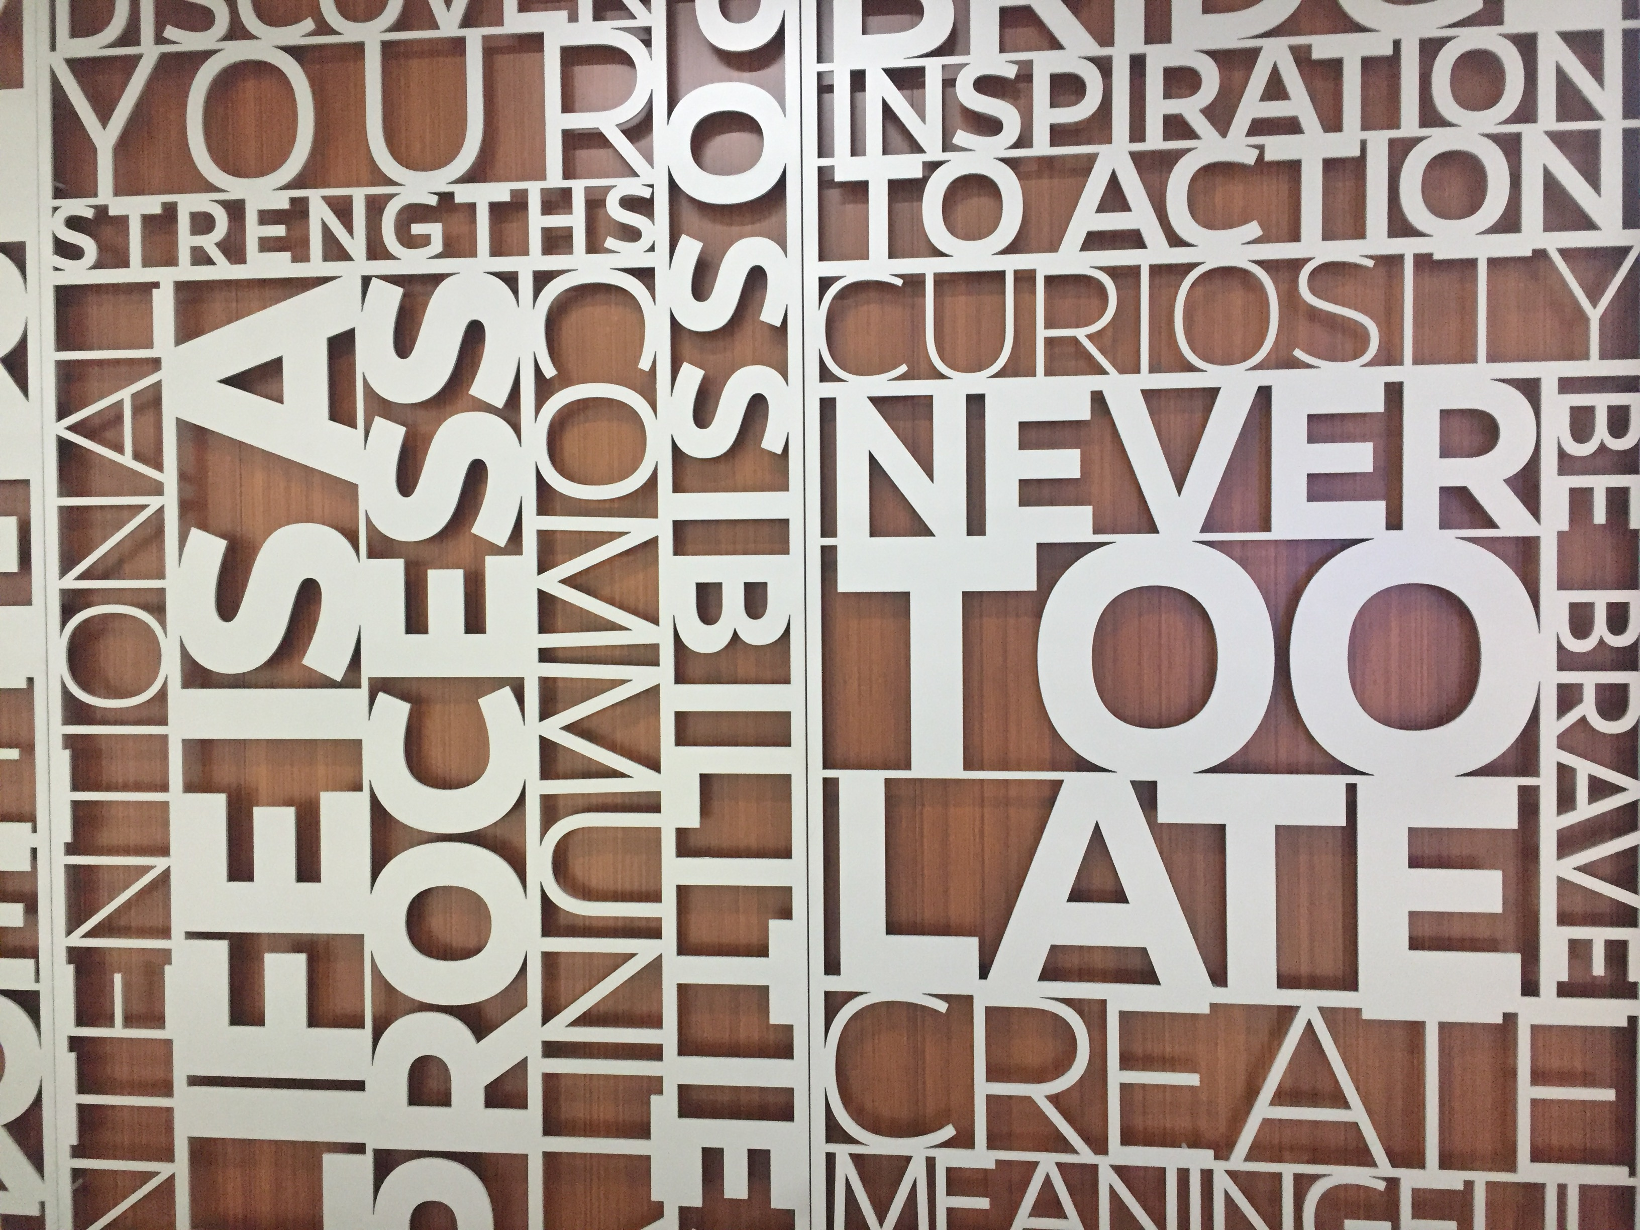
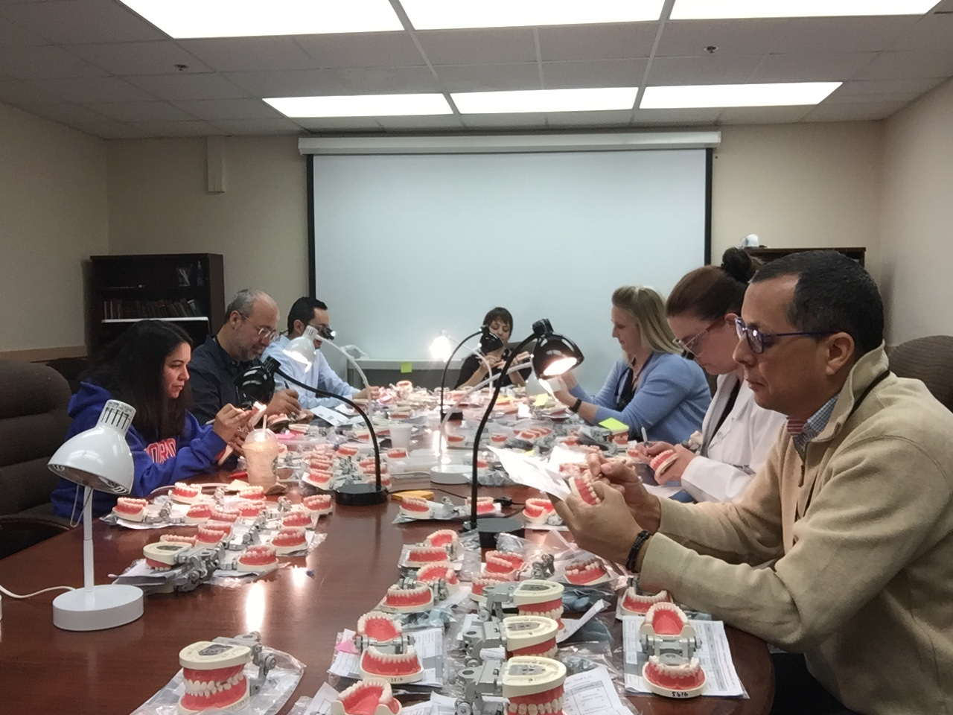
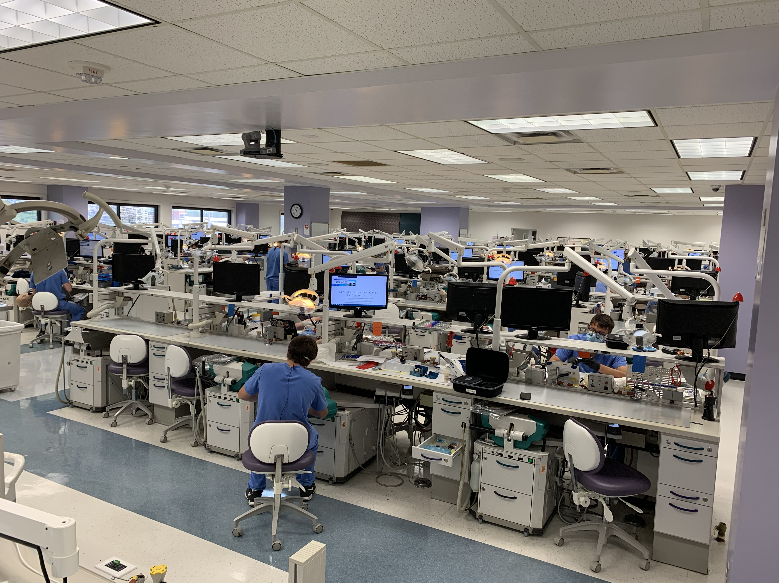
Course Description:

DEN6412C: Preclinical Fixed Prosthodontics I
  - Fall 2020
  - Your Family Name
To lay the foundation for fixed prosthodontics by using the knowledge of dental materials, jaw motion, anatomy and physiology along with the correlation and coordination of knowledge and skills from every area of dentistry.

I. General Information

Course Director:

Carlos Soucy
Office: D9-39D
Email: CSoucy@dental.ufl.edu
Phone: (352) 273-5850
Course Credits: 2
Semester: Fall
Office Hours: To be announced in the introductory lecture

Assistant Course Director:

Alexandre Cabrera
Office :D9-29C
Email: alexcabrera@dental.ufl.edu
Phone: (352) 273-6921

Contributing Faculty

Maria Aguilar (352) 273-6917 maguilar@dental.ufl.edu
Monica Fernandez (352) 273-9504 mfernandez@dental.ufl.edu
Cara Clark Hill (863) 512-1188 CHill2@dental.ufl.edu
Luisa Echeto (352) 273-6907 lecheto@dental.ufl.edu
Sheriff Hosney (352) 273-5839 shosney@ufl.edu
Panagiotis Zoidis D9-29C pzoidis@dental.ufl.edu
Bruna Garcia BGarcia@dental.ufl.edu

Support Staff

Elaina Buono (352) 273-6904 ebuono@dental.ufl.edu/ Grade Administrator
Michelle R Watson (352) 273-5830 mwatson@dental.ufl.edu TA / Grade Administrator
Michele L Cooley (352) 273-5711 mcooley@dental.ufl.edu
Mindy Lee-Walker (352) 273-6904 MLee-Walker@dental.ufl.edu
Jerri E Wainer (352) 273-6825 jwainer@dental.ufl.edu

Prerequisite course:
- Occlusion is a prerequisite for Fixed Prosthodontics I, Fixed Prosthodontics II, Complete Dentures, Removable Prosthodontics, and Implant Dentistry
- Fixed Prosthodontics I, Fixed Prosthodontics II, Complete Dentures, and Removable Prosthodontics are all prerequisites for Implant Dentistry
- Fixed Prosthodontics I is a prerequisite for Fixed Prosthodontics II

Successful completion of this course is required to progress to DEN6415. It is a required pre-requisite; a student may not continue in the next course in a series if they do not successfully pass or successfully remediate the prior course.

Successful completion of this course is required before any student is permitted to provide patient care in the TEAMs Clinics (DMD clinical courses), clinical rotations involving patient care, offsite rotations that require providing clinical patient care, and volunteer opportunities involving direct provision of patient care. Students may be permitted to assist and take radiographs with authorization from the Associate Dean for Clinical Affairs and Quality Assurance.

II. Course Goals
The educational goal of this course is to promote mastery of the knowledge and skills necessary to perform fixed prosthodontic procedures on your future patients. The clinical practice of fixed prosthodontics requires the dentist to apply fundamentals that meet the biological, mechanical, and esthetic requirements of each restorative situation. This course will provide the basic information necessary to diagnose, plan and perform fixed prosthodontic restorative procedures. Upon successful completion of this course, you should be able to prepare teeth for a full gold crown, a porcelain-fused-to-metal crown and an all ceramic crown and make a provisional restoration for the preparation. In addition, the concepts and principles of tooth preparation and dental laboratory procedures will be applied to dentoform teeth while the cognitive and psychomotor skills are being developed. Knowledge of dental laboratory procedures and development of dental laboratory skills will enable you to more efficiently perform clinical dentistry. You will become well prepared to delegate this work to a dental technician while maintaining your standard of quality once you enter practice.

III. Course Overview
This is a lecture and laboratory course. Students will use critical thinking in the self-assessment of psychomotor projects.
Successful completion of this course is required to progress to DEN6415C: Preclinical Fixed Prosthodontics II. It is a required prerequisite.

IV. Course Outline

A. Basic Concepts of Fixed Prosthodontics: Single-Unit Restorations
B. Basic Concepts of Provisional Restorations: Single-Unit Provisional Fabrication
C. Dental Materials for Prosthodontics

V. Course Material

Required texts:

- Required text books:

- Shillingburg, H.T.; Hobo S.; and Whitsett, L.D. (2012) “Fundamentals of Fixed Prosthodontics, 4th ed”. Quintessence Pub. Co ISBN 780867154757. 9780867155174.
- "Phillips' Science of Dental Materials" by Kenneth J. Anusavice; H. Ralph Rawls; Chiayi Shen.;12th ed., Elsevier, 2012. ISBN-13: 978-1437724189
3. Package #1: Welsch, BB, Criteria for Crown Preparations and Provisional Restorations.
4. Models provided by the department:
- #1: Fujimoto, J. Step-by-step tooth preparation model of a mandibular molar full metal crown
- #2: Fujimoto, J. Step-by step tooth preparation model of a maxillary central metal ceramic crown
- #3: Taper model

5. Lecture presentation can be found in Canvas
6. A collection of procedural videos can be found in Canvas
7. Glossary of Prosthodontic Terms. Available free online at:
http://www.academyofprosthodontics.org/_Library/ap_articles_download/GPT9.pdf

Additional Resources:
Dental Lib Guide: http://guides.uflib.ufl.edu/dental
Required textbooks: Textbooks can be ordered online or rented/purchased in the Health Science Center bookstore on the ground floor next to the Post Office. Students also have access to e-versions through the Dental Lib Guide link. Please work with your department chair, division director, and the Office of Academic Affairs if you plan to change the textbook for the course. This affects other courses and needs to be discussed prior to changing.
Dental Lib Guide: http://guides.uflib.ufl.edu/dental
Other Resources:

Course presentations, reading assignments, and handouts will be posted in Canvas. http://lss.at.ufl.edu

VI. Course Objectives

Didactic Objectives:

This course will use a combination of lecture (direct instruction) and laboratory (psychomotor) exercises to accomplish the following learning objectives.
- Basic Concepts of Fixed Prosthodontics: Single-Unit Cast Restorations
  - Define the standard prosthodontic terms.
  - Prepare anterior and posterior dentoform teeth for any full veneer restoration to meet the criteria given in the self-instructional material.
  - Be able to apply the fundamentals of tooth preparation to dentoform teeth.
- Basic Concepts of Provisionalization
  - Prepare anterior or posterior dentoform teeth for any situation requiring a full cast, porcelain fused to metal or all ceramic crown to meet the criteria given in the self-instructional material.
  - Fabricate a provisional using any of the various techniques, metal shell, polycarbonate, and custom.
  - Make a final impression and prepare casts for submission to a dental laboratory.
- Dental Materials for Prosthodontics
  - Metals and Alloys
    - Describe the atomic structure of metals and discuss how the structure dictates the following metallic characteristics: surface appearance, electrical and thermal conductivity, ductility and malleability, fracture toughness, and chemical resistance.
    - Describe solidification of metal by using terms such as homogeneous and heterogeneous nucleation, dendrites, grain, and polycrystalline.
    - Discuss the effect of grain size on the yield strength of metal and two methods of reducing grain size of a metal.
    - Define an alloy and identify the difference between an alloy and an alloy system.
    - Define solid solution, solute and solvent of an alloy.
    - The use of gold-copper alloy system to illustrate super lattice; explain why binary solid solution alloys usually are stronger and harder than either of the original metals, and why the maximal hardness of solid solutions is reached at approximately 50 atomic percent of each metal.
    - Describe construction of a phase diagram, and identify liquidus and the solidus lines of a phase diagram; draw an eutectic alloy system and describe the characteristic of the eutectic system.
    - Compare and contrast the terms quenching and heat treatment; to use gold-copper system to discuss how you can make a gold alloy be soft initially and then make it soft or hard as you wish through the process of quenching, solution heat treatment and age-hardening treatment.
    - Discuss the difference between cast alloy and wrought alloy, and describe how we can turn a cast alloy to a wrought alloy.
    - Describe the interaction between atoms during plastic deformation of cast alloys; discuss the role of edge dislocation in facilitating slippage of atoms within the alloy.
    - Explain why an alloy, containing moveable dislocations, will have a lower elastic limit than an alloy of the same composition without movable dislocations.
    - Identify four mechanisms of strengthening alloys involving dislocations, and explain why a metal being bent back and forth (cold worked) becomes less ductile and eventually breaks.
    - Define annealing of alloys and identify the three stages of an annealing process; relate these stages to changes in structure as well as in tensile strength and ductility of the alloy.
  - Casting Alloys for All-metal and Metal-ceramic Prostheses
    - Discuss the desired properties of dental casting alloys.
    - Classify dental alloys based on: a) karat and fineness (gold alloy only), b) noble metal content, c) mechanical properties, d) principal elements and e) clinical applications.
    - Discuss the relevance of elastic modulus, yield strength, hardness, ductility and density of the alloys regarding their dental applications.
    - Define the rigidity of dental prostheses and discuss factors that dictate the rigidity of any device.
    - Discuss the difference in requirements of mechanical properties between fixed and removable partial dentures.
    - Describe the structural difference between all-metal cast prosthesis and metal-ceramics prosthesis, and discuss additional requirements of the alloys for metal-ceramic prostheses.
    - Explain the mechanisms of bonding ceramic to alloys.
    - Discuss the thermal compatibility of metal-ceramic systems and the effect of resultant residual stress at the metal-ceramic interface.
    - Discuss the benefits and drawbacks of metal-ceramic prostheses.
    - Discuss discoloration of porcelain by silver.
    - Describe alloy systems used for fixed partial denture, removable partial denture and metal-ceramic prostheses.
    - Briefly describe dental casting procedure and discuss causes of dental casting shrinkage; discuss how you can obtain a precise casting in spite of known shrinkage.
    - Discuss potential hazard of processing Ni-Cr-Be alloys to the dental laboratory technician, the clinician and list all relevant precautions.
  - Dental Ceramics
    - Identify the principal mineral ingredients used in dental porcelain and distinguish between the crystalline and glass components of the fused structure.
    - Describe the physical changes that occur during the condensation and firing of dental porcelain.
    - Explain on a physical basis why the tensile strength of a brittle material, like dental ceramic, is significantly lower than its compressive strength.
    - Discuss the following means of enhancing mechanical properties of dental porcelain: ion exchange, thermal tempering, thermal expansion coefficient mismatch, crystalline dispersion phase and metal-ceramic.
    - Discuss the design principles of dental ceramic restorations.
    - Describe current all-ceramic materials by composition and by processing technology.
    - Discuss the role of zirconium oxide in enhancing fracture resistance of yttria-stabilized zirconia; the process is also known as transformation toughening.
    - Discuss the significance of chemical stability and abrasiveness of dental ceramic in clinical applications.
  - Provisional Materials
    - Describe basic requirements of a provisional restoration.
    - Classify provisional restorations by the form of materials supplied and processing.
    - Describe current material systems used for custom making provisional restorations.
    - Recognize the relevant properties of provisional materials.
    - Discuss the type of cement for cementing provisional restorations.
    - Describe techniques of fabricating provisional prostheses.
    - Discuss problems associated with making provisional prostheses.
- Single unit restorations
  - Identify the preparation features that influence the character and the prognosis of full cast metal and metal-ceramic restorations.
  - Identify the various margin configurations available for use in full cast metal and metal-ceramic restorations and indications for each.
  - Demonstrate material dimensions required which achieve the restorative goals.
  - Develop a rational approach to systematic tooth preparation for full cast metal and metal-ceramic restorations.
- All ceramic restorations
  - Identify the preparation features that influence the character and the prognosis of all-ceramic restorations.
  - Identify the advantages/disadvantages, indicators for use, types (materials), fabrication and cementation techniques.
  - Describe cementation procedures associated with these restorations.
- Dental Ceramic
  - Identify the principal mineral ingredients used in dental porcelain and distinguish between the crystalline and glass components of the fused structure.
  - Describe the physical changes that occur during the condensation and firing of dental porcelain.
  - Explain on a physical basis why the tensile strength of a brittle material, like dental ceramic, is significantly lower than its compressive strength.
  - Discuss the following means of manipulating mechanical properties of dental porcelain: ion exchange, thermal tempering, thermal expansion coefficient mismatch, crystalline dispersion phase and metal-ceramic.
  - Discuss the design principles of dental ceramic restorations.
  - Familiarize all-ceramic materials by composition and by processing technology.
  - Discuss the metal-ceramic interface and technical consideration of metal-ceramic restoration.
  - Discuss the significance of chemical stability and abrasiveness of dental ceramic in clinical applications.

Preclinical SimLab Objectives:

- Module #1: Full Metal Crowns
  - Be aware of the glossary of prosthodontic terms
  - Identify lab fabrication techniques for metal prosthesis
  - Follow the instructions demonstration ergonomic patient, operator, and assistant positioning
  - Associate with mental map of the procedure to be performed
  - Identify possible issues with the preparations
  - Replicate techniques for full gold crown restorations in simlab outside mannequin
  - Practice techniques for full gold restoration that align with the calibrated rubric
  - Improve efficiency with full gold restorations under timed conditions
  - Demonstrate technique for gold restoration on mannequin accurately and efficiently
  - Understand how to fix a possible situation with the dental procedure that is not going well
  - Perform gold restoration techniques automatically with proficiency on a mannequin

- Module #2: Porcelain Fused to Metal Crowns
  - Adopt the terminology of the “glossary of prosthodontic terms”
  - Create a mental map of the procedure to be performed
  - Practice techniques for PFM restorations in the simlab on the bench
  - Replicate techniques for PFM restorations in the simlab on the bench
  - Improve efficiency with PFM restorations under timed conditions
  - Demonstrate technique for PFM on a mannequin accurately and efficiently
  - Perform PFM restoration techniques automatically with proficiency on a mannequin

- Module #3: Provisional Crowns
  - Select a material for provision restoration that works best in your hands
  - Perform consistently while setting in the proper ergonomic position with instructor feedback
  - Replicate techniques for provisional restorations in SimLab on the bench
  - Practice techniques for provisional restorations in SimLab on the bench
  - Improve efficiency with provisional restorations under timed conditions
  - Demonstrate techniques for provisional restorations on a mannequin accurately and efficiently
  - Perform provisional techniques automatically with proficiency on a mannequin

- Module #4: All Ceramic Crowns
  - Perform ergonomic positioning correctly and automatically without guidance.
  - List the advantages and disadvantages of different lab techniques for all ceramic crowns.
  - Replicate techniques for ACC restorations in the SimLab on the bench
  - Practice techniques for ACC restorations that align with the calibrated rubric.
  - Improve efficiency with ACC restorations under timed conditions.
  - Demonstrate technique for ACC restorations on a mannequin accurately and efficiently.
  - Perform ACC restoration techniques automatically with proficiency on a mannequin.

VII. Course Competencies

This course teaches the following competencies in the "Competencies for the New Dental Graduate".
Domain I: Critical Thinking
1: Critical Thinking: Use critical thinking and problem-solving, including their use in the comprehensive care of patients, scientific inquiry andresearch methodology.
2: Evidence-Based Patient Care: Access, critically appraise, apply and communicate scientific and lay literature as it relates to providing evidence-based patient care.
Domain VI: Patient Care - B. Establishment and Maintenance of Oral Health
18: Provide oral health care within the scope of general dentistry to include communicating and managing dental laboratory procedures in support of patient care.
19: Provide oral health care within the scope of general dentistry to include replacement of teeth including fixed, removable and dental implant prosthodontic therapies.

VIII. Evaluation
The evaluation in this course is based on your cognitive and psychomotor skills, your understanding of the didactic material, and your ability to apply fundamentals to simulated situations.
Evaluation of student performance will consist of:
1) Written Examinations and Quizzes
2) Psychomotor exams (5)
3) Projects
Students must pass EACH of the sections (Didactic and Psychomotor) with a grade of 72% to pass this course.

1) Didactic section (50%):
This section is given to assess your understanding and application of the didactic material. It includes a midterm examination, 3 out of 4 scheduled quizzes, and a cumulative final examination that will cover all material. The final didactic section grade will be the average grade between the quiz average, the midterm, and the final exam grades. A minimum passing grade of 72% is required. Questions will be made from the lectures and the suggested reading material during the course.

1A) Quizzes
The quiz is given at the beginning of a scheduled class or lab session for each team; you must be seated by the class's scheduled starting time. Those who arrive after five minutes or after the quiz begins will not be allowed to take the exam. Quizzes may be given at a time other than at the start of the lecture. For example,during a break in the middle of a lab session or at the end of it. The course director will determine the allowed time for the quiz.

1B) Written Exams
You will have a Midterm and a Final Exam. The final will be cumulative. Questions can be in the form of multiple choice, true/false, fill in the blank,
drawings, short answer, patient box questions and/or essay.

2) Psychomotor Section (50%):
This section is designed to assess your psychomotor skills and your ability to apply fundamentals to simulated situations. There will be a total of 8 projects and 3 psychomotor examinations with 5 different activities to be graded. Psychomotor Grade Scale. Student performance is evaluated by an orderly decision-making process. Procedural items are scored 4, 3, 2, or 1 against defined criteria.
- Four (4) indicates that the criteria were met at a superior level
- Three (3) indicates that the criteria were met at an acceptable level
- Two (2) indicates that modifications are necessary to achieve an acceptable level
- One (1) indicates that the outcome was measured to be at an unacceptable level
For each criterion an evaluative modifier (+) can be assigned to a 1, 2, or 3 grade to indicate that the student identified an error prior to faculty evaluation. Proper terminology and specific locations of all errors must be noted by the student in writing. General non-specific statements will not justify a (+) modifier.
A “1” or "1+" score on any of the criteria on a psychomotor exam will result in a failing grade. The percentage assigned is 65% or the actual percentage score, whichever is lower when a score of 1 is given. The percentage assigned is 70% or the actual score, whichever is lower when a score of 1+ is given.
Points are calculated as follows:
4 = 4 points
3+ = 3.25 points
3 = 3 points
2+ =2.25 points
2 = 2 points
1+ =0.25 point
1 = 0 points
A score of 2.5 is considered a passing score and equals 72%.
Students who fail a psychomotor exam are required to participate in a reassessment process at the end of the course. The reassessment will not change the previous grade obtained in the psychomotor exam. Reassessment is required since students are expected to complete all of the restorations taught in this course while providing patient care. It is essential that the skill be demonstrated at an acceptable level before advancing to the next course and and before providing patient care.
Daily Laboratory Formative Feedback. Daily projects will be assessed by the student first and then by the faculty. The intent is to teach the student to self-assess their work accurately to help them identify gaps in skill and/or knowledge and target areas that need improvement.

2A) Laboratory projects

Students are responsible for completing all assigned laboratory projects up to the course standards. Self-evaluation and the development of critical analysis are important in the learning process. For each project, you will be expected to evaluate your work on the grading form before asking a faculty member to critique the procedure.
The grading criterion is designed to have the student grade him/herself first and then the faculty may agree or disagree with the student’s self-assessment. Students will be expected to correct the errors but no grade changing will occur after corrections are made. All projects are graded pass/fail. You're responsible for turning the project sheet signed and complete by the attending faculty on the due date printed on the form.
1. Full metal crown preparation on tooth #2 benchtop (note: this is the only benchtop project)
2. Full metal crown preparation on tooth #30
3. Porcelain Fused to metal crown preparation on tooth #13
4. Provisional crown fabrication using a putty matrix and Bisacryl (Tempsmart) on tooth #13
5. Provisional crown fabrication using a putty matrix and PMMA (Snap) on tooth #13
6. Porcelain Fused to Metal Crown preparation #18 with a provisional (material chosen by student)
7. All Ceramic Crown Preparation and provisional on tooth #6 (material chosen by student)
8. All Ceramic Crown Preparation and provisional on tooth #8 (material chosen by student)
**Students who are absent from any project due date in this course for any reason other than an emergency (with documentation), will be required to turn in the missed project as soon as possible, but no later than 1 week after their return to class.**

2B) Psychomotor Exams

1. Full metal crown preparation #3 (20%)
2. Metal ceramic preparation (20%) with provisional #12 (20%)
3. All ceramic crown preparation (20%) and provisional restoration #9 (20%)
The final psychomotor section grade will be the average between the 5 psychomotor examination activities. Students must pass 2 of the 3 psychomotor examination in this course to pass the course. A minimum passing grade of 72% is required.

RDS Departmental Course Policies:

1. There will be no make-up quizzes. You are permitted to drop one (1) of the quizzes during the course. The only exceptions are for hospitalization, family emergencies, and excused rotations. Students who are approved by the course director for a makeup quiz in one of these rare and extreme circumstances will schedule to take the make up with Ms. Michelle Hopkins in D9-6 during business hours. The quiz may be in a different format (i.e. essay, fill in the blank, ora , etc.) than the original multiple choice quiz.
2. Missed psychomotor examinations will require a doctor’s note and if excused, the make-up exam will be a similar to the scheduled examination but may include different teeth and/or surfaces. The make-up examination must be scheduled within 2 business days of the missed exam or the student’s return to school. The highest attainable grade on a missed exam is an 85%.
3. Missed written (Midterm and Final) or station examinations (Psychomotors) will require a doctor’s note and if excused, the make-up exam will be either an essay or oral examination. The make-up examination must be scheduled within 2 business days of the missed exam or the student’s return to school. The highest attainable grade on a missed exam is an 85%.
4. Due to time constraints there are no retake examinations during (within) courses. Students are required to demonstrate that they can pass the
examinations they fail. This will be completed during the week set aside for remediation. These reassessment exams are required to pass the
course but they will not affect your grade at all, it serves to demonstrate you can move on to the next course (DEN6415).
5. If a course is failed, an “E” grade will be issued and the student will remediate the course.
6. The psychomotor and didactic sections of each course must be passed with a minimum of 72%in order to pass the course.
7. Students must pass the majority of the psychomotor examinations in the course to pass the course (3/5). The student should also pass (3/5 preparations and 2/4 provisional restorations).
8. A student may not continue in the next course in a series if they do not successfully pass or successfully remediate the prior course. The courseDEN6213 is the prerequisite for this course (DEN6412) and this course is a prerequisite for DEN6415 Fixed Prosthodontics II course.
In order to pass this course (DEN6412) you must have:
1. The didactic section must be passed independently with 72% or above
2. The psychomotor exams must be passed independently with a 72% or above. You must pass 3 of the 5 examination activities to pass this course.
3. A final grade of 72% or above – average grade of didactic (50%) and written portion (50%).
4. The Lab Project Sheet must be complete and turned in on the printed date of the form.

Professional Conduct.

The College of Dentistry expects all dental students to be professional in their dealings with patients, colleagues, faculty and staff. Professional and ethical conduct is a mandatory qualification for every practicing dentist.
Working on dentoform teeth outside of the dentoform or mannequin, positioning the dentoform in any unnatural position in the mannequin, working after the allotted working time is over, working on any teeth other than the exam teeth given to you the day of the exam, falsifying any documents, among others is a violation of the student honor code and will result in an automatic failing grade for entire course, immediate referral to the SPEC and may result in other sanctions as well. The only exception is if a student inadvertently prepares the wrong tooth. This will result in an automatic failure for the exam and not for the entire course.
Attendance and adherence to the dress code are mandatory. In addition, for each lecture and laboratory session, students are expected to be prepared, complete the self-assessment forms, follow all guidelines and instructions (which includes use of iPods, headphones, etc.), and put forth an excellent effort (work the entire lab session, work diligently and make every effort to get the most out of every session).
Professional misconduct observed during lectures, exams, quizzes, and laboratory sessions will result in an Academic Variance (see Pre-doctoral Student Handbook). Five percentage points will be deducted from the final course grade for each academic variance issued.

Adherence to the Dress Code.
Please help us as we teach you to be the excellent healthcare providers you aspire to become in the future.
1. Use proper PPE and follow infection control protocols for patient care
2. Make yourself available to hear your patient and instructor and do not use headphones or play music at your station.
3. Use of phones should be limited to emergency situations. Please keep out of sight until the end of class.
4. Earplugs will be provided at the beginning of psychomotor examinations, including mock exams if you want to use them.

Students must adhere to the dress code as spelled out in the Pre-doctoral Student Handbook and Clinic Procedure Manual while enrolled in any course in the Department of Restorative Dental Sciences. It is always applicable including, lectures, exams, quizzes, and laboratory sessions. Failure to comply with the dress code will result in a reduction in your final course grade as follows:
- 1st Offense - Student will be asked to leave the class and warned
- 2nd Offense - Student will be asked to leave the class and a 5% reduction in your final course percentage will be imposed
- 3rd Offense - Student will be asked to leave the class and an additional 5% (10% total for dress code) reduction in your final course percentage will be imposed
- 4th Offense - Student will be asked to leave the class and an additional 5% (15% total for dress code) reduction in your final course percentage will be imposed
- 5th Offense - Student will be issued an "E" grade in the course

Students will receive a grade of 0 on a psychomotor exam for any of the following:
- Changing or removing any teeth during or after a psychomotor examination. (Dental anatomy allows the student to take the tooth out while waxing but teeth cannot be changed or replaced during the exam.)
- Working on the dentoform in any manner that is unnatural (such as upside down, placing the upper arch in the lower arch position and vice versa).
- Not placing the dentoform on the cart immediately after the exam ends.
- Working on the dentoform outside of the manikin for a manikin exam.
- Missing a tooth or teeth adjacent to the exam tooth/teeth.
- Remove the tooth/teeth or dentoform and leave the exam room with it/them.
Students will lose 50 points off on the psychomotor exam grade if they:
- Prepare or restoring the wrong tooth.
- Do not have all teeth in the dentoform.
The grades for the final written exam, psychomotor exam, and final course grade will not be posted at the end of the semester, until 70% of students have completed the faculty evaluations.

Course Remediation
Students failing the course will be awarded an "E" grade, referred to the Student Performance Evaluation Committee (SPEC), and be placed on academic probation. The student must meet with the course director to develop a remediation plan within one week of the notification of the failing final grade. The remediation activities are at the discretion of the course director. Faculty are available to assist students as they prepare for this examination, but the responsibility for learning the material resides with the student. The time, place, content, and passing grade of the remediation program will be individualized for each student and arranged by the course director. Please note that remediation activities are often best completed during student break weeks to keep the student on track with other courses the following semester.
The highest grade attainable in a remediated course is a “D". Students failing to satisfactorily complete the remediation program will maintain the "E" grade and will automatically be referred to SPEC. For more information refer to the Administrative Practices Section K: Remediation.
Please note that if the course director determines that the student failed the coursework to such an extent that remedial activities would be inadequate to attain an acceptable level of academic achievement in the course material, the course director can elect not to provide remediation.
A failing grade awarded in any course will remain on the permanent record. Any grade achieved after re-enrollment will be listed separately. In addition, the following adjustments will be made to the final course grades:

Attendance
- 5% points will be deducted from the psychomotor course portion final grade for each lab missed without an excused absence.
- 5% points will be deducted from the psychomotor course portion final grade for every three unexcused instances of tardiness.
- 5% points will be deducted from the psychomotor course portion final grade if the grading forms are not returned complete and signed by faculty by the date established by the course director when turned in after the due date.

Faculty Evaluation
“Students are expected to provide professional and respectful feedback on the quality of instruction in this course by completing course evaluations online via GatorEvals. Guidance on how to give feedback in a professional and respectful manner is available at https://ufl.bluera.com/ufl/. Students will be notified when the evaluation period opens, and can complete evaluations through the email they receive from GatorEvals, in their Canvas course menu under GatorEvals, or via https://ufl.bluera.com/ufl/ . Summaries of course evaluation results are available to students at https://gatorevals.aa.ufl.edu/public-results/

IX. Administrative Practices
Administrative practices for all UFCD courses are universally applied. Exceptions to or deviations from these practices are stated in the individual syllabi by the course director. When not individually stated in the syllabus, course administrative practices default to those identified under "Course Policies" on the DMD Student Website:
https://dental.ufl.edu/education/dmd-program/course-policies/
X. Grade Scale
DEN6412C Grade Scale
Method Letter Grade Scale 100Tolerance 0.5 (Final letter grades within this range will be rounded up.)
A 95 - 100
A- 90 - 95
B+ 86 - 90
B 82 - 86
B- 80 - 82
C+ 74 - 80
C 72 - 74
E 0 - 72

