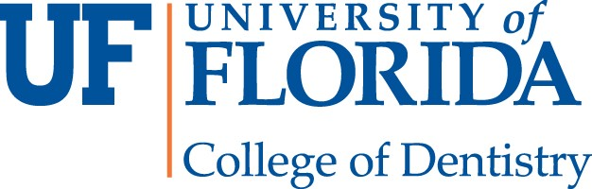
Application Deadline for Applications: May 1st, 2019
Impressions Program 2019

PERSONAL INFORMATION
First Name Initial Last Name
Gender Ethnicity (Optional) Age
Phone Number E-mail
CURRENT ADDRESS  Address |  |  |  |  | Apt/Unit #
City |  |  | State |  | Zip Code
PERMANENT ADDRESS  Address |  |  |  |  | Apt/Unit #
City |  |  | State |  | Zip Code
ACADEMIC INFORMATION  Name of  Institution  Major/Minor  Current Status (Place asterisk on selection/ underline) | Freshman | Sophomore | Junior | Senior
Institution  Address  City |  |  | State |  | Zip Code
ADDITIONAL INFORMATION
T-shirt Size (underline) Small  Family's Socioeconomic Status (Optional) | Medium | Large | X- Large
Lower SES Middle SES | Upper SES
Food Allergies?
PRE-DENTAL EXPERIENCES: Please answer the dental-related questions below by Underlining the selected choice
1. Have you had any shadowing experience in a dental office or clinic?  Yes No | 2. Have you ever worked in a dental office?  Yes No
3. Have you ever done any dental related community service?  Yes No | 4. Have you ever had any dental related research experience?  Yes No
5. Have you done any dental-related mission trips?  Yes No | 6. Do you have any family members/relatives who are dentists?  Yes No
7. Have you participated in an Impressions Program before?  Yes No | 8. Have you ever applied to dental school before?  Yes No
If answered "Yes" to any of the above questions, please briefly explain below:
EMERGENCY CONTACT  Primary Contact Name | Relationship | Phone Number
Secondary Contact Name | Relationship | Phone
I am aware that the Impressions Program will take place at the University of Florida College of Dentistry in Gainesville, FL.
Yes No
I am aware that the Impressions Program is a full-day event scheduled for June 1th, 2019
Yes No
If selected, I am aware that I must attend all portions of the Impressions Program.
Yes No
I am aware of the application deadline and understand that my application will not be considered if submitted past this date
Yes No
I PLEDGE THAT ALL INFORMATION IS ACCURATE AND TO THE BEST OF MY KNOWLEDGE
Signature Date
*Typing your name can and will serve as an official signature*
Short Answer Question #1:
There is a shortage of access to dental care. In most cases, this is due to a shortage of practitioners in under-served communities. One approach to solving this pressing issue is to get more minorities and individuals from under-served communities to become dentists in hopes that they will return to their communities and increase access to care. In the space provided (500 word limit), state what you think about the above approach. Use past experiences to support your thoughts.
Short Answer Question #2:
Why does the field of dentistry interest you, and how will you benefit from participating in the Impressions Program?
(500 word limit)
IMPORTANT: Application must be completed and submitted by May, 1st, 2019 to be considered.
Please e-mail ufcdsnda@dental.ufl.edu for any questions, concerns, AND to submit your application. **Notifications on the decision of applications will BEGIN May 2nd, 2019. Please give us some time to review your application and send out emails with acceptance.

